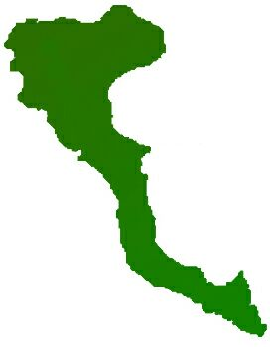

|  |  |
| --- | --- |
| **Team: 3-D Protocol number: 1** | |
|  | |
| **Author: Arenas Pérez, Pedro José** | **Date**: 3.11.2020 |
| **Participants:**  - Adnan, Muhammad  - Arenas, Pedro  - Ashar, Shazeem  - Shahid, Arsalan  - Ur Rehman, Mutee | |

| **Protocol of the meeting of 3 November 2020** | |
| --- | --- |
| **Topic** | **Results** |
| Find project idea | Sections "Project Idea" & “Application Structure” of the "Readme.md" file in the project repository |
| Choose tech stack | Section “Tech Stack” of the “Readme.md” file in the project repository |
| Choose first team leader | Arenas, Pedro will have the team leader role until the first change of team leader. |
| Choose protocol responsible | Arenas, Pedro will be responsible for defining the template of the protocol and writing it up after each meeting |